# Settings.

1. Rights for the users. It is not seen because the level of the user is not allowing to see the rights.
2. Path setting :
   1. Path type “File export” – In which directory the system exports files. This export is mainly connected with export of data from tables.
   2. Path type “Transfer” – From which directory systems takes files and puts files with buttons “From Transfer” and “To Transfer”

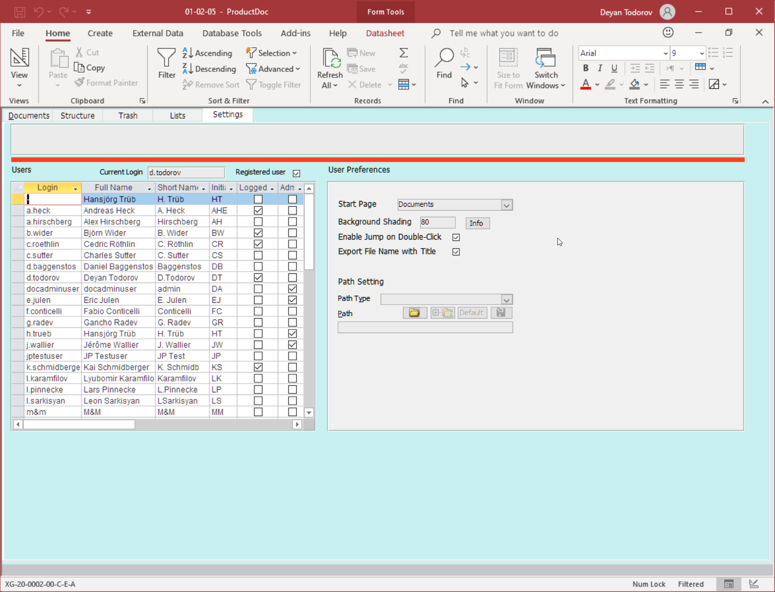

# Lists

There are 3 main lists with data used for properties of the documents:

1. Document types:

Short Name

Description of the type

Is it enabled for use and if it allows to be used for nw documents.

Who modified it last

When it was modified

1. Status of the document:

Status

Who modified it last

When it was modified

1. Language of the document

Short name

Name

Who modified it last

When it was modified

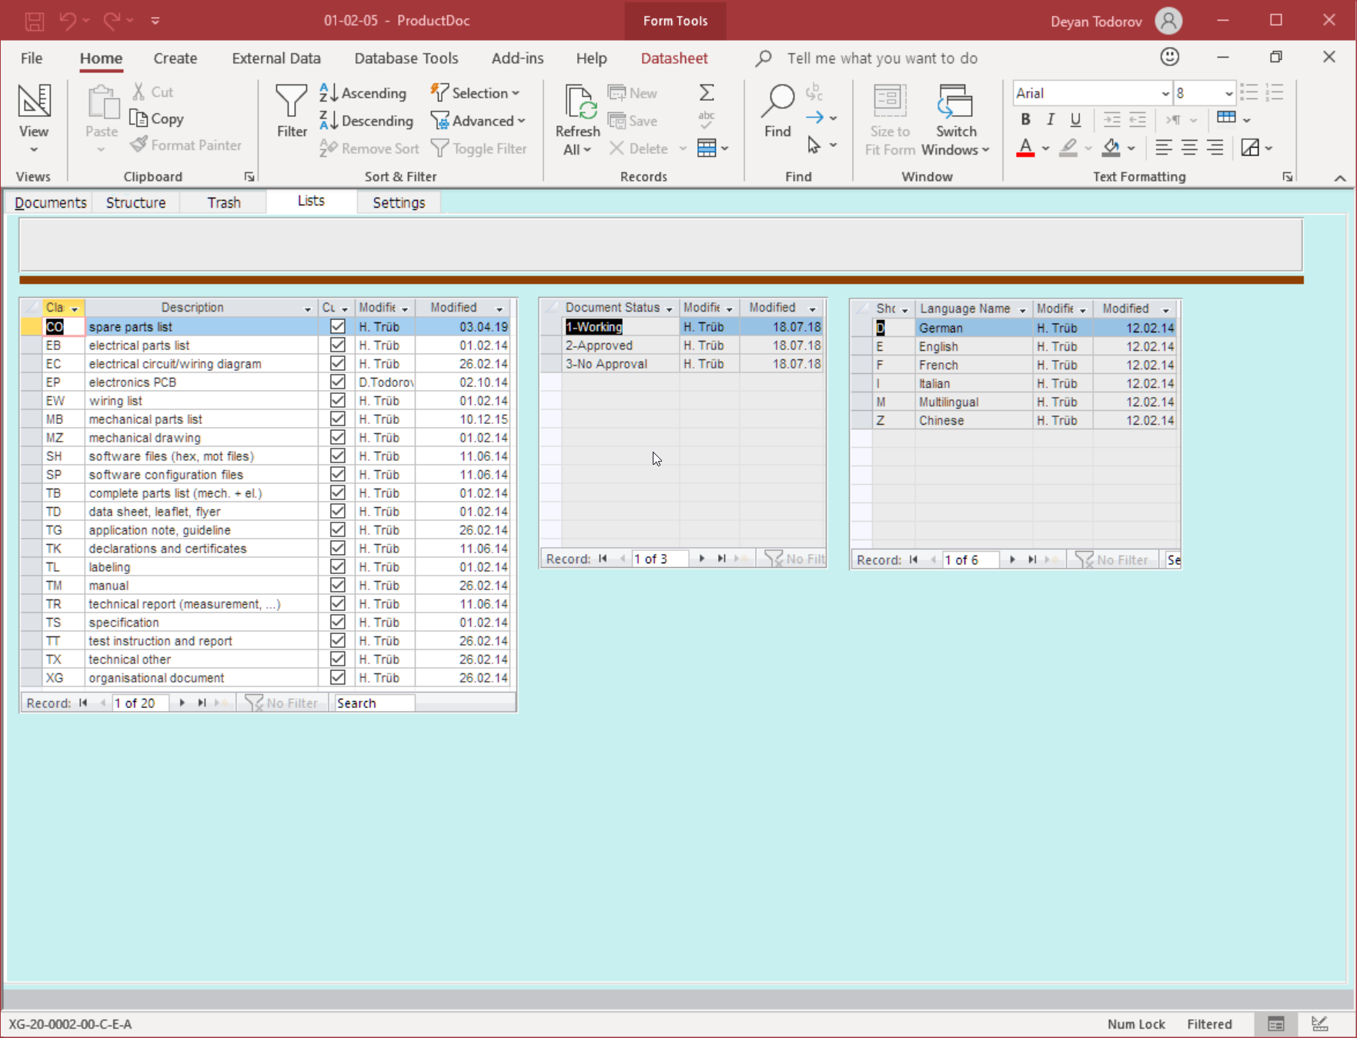

# Trash

Documents are never deleted. When delete is pressed they go to a trash directory and trash table. When the document is moved also the name of the user who deleted the document get’s stored.

